**WILDFIRE TRACKER**

BY: ABHILASH KUMAR BEHERA and IPSITA BEHERA

(B.TECH 1ST YEAR DEPARTMENT OF COMPUTER SCIENCE AND ENGINEERING, SIKSHA ‘O’ ANUSANDHAN DEEMED TO BE UNIVERSITY,BHUBANESWAR,ODISHA)

EMAIL ID: [abhilashkumar228@gmail.com](mailto:abhilashkumar228@gmail.com)

[beheraipsita28@gmail.com](mailto:beheraipsita28@gmail.com)

ABSTRACT: This paper synthesizes understanding of the potential effects of changing climate and fire regimes including effects on disturbance and stress interactions, forest structure and composition, and post-fire ecological processes. It basically uses the EONET API (The Earth Observatory Natural Event Tracker) and Google map for tracking wildfires across the world and to make people aware of the situation around them. It allows the user to check current wildfires around the world at real time.

KEYWORDS:

Climate change, Wildfire, Fire regimes, Google maps,

EONET API: The Earth Observatory Natural Event tracker

INTRODUCTION: A wildfire, bushfire or wild land fire is an unplanned, unwanted, uncontrolled fire in an area of combustible vegetation starting in rural areas and urban areas. Depending upon the type of vegetation present, a wildfire can also be classified more specifically as a forest fire. The occurrence of wildfires throughout the history of terrestrial life invites conjecture that fire must have had pronounced evolutionary effects on most ecosystem’s flora and fauna.

Wildfires can be characterized in terms of the cause of ignition, their physical properties, the combustible material present, and the effect of weather on the fire. It can cause damage to property and human life although naturally occurring wildfires may have beneficial effects on native available fuels, physical setting, and weather. Wildfires are among the most common forms of natural disaster in some regions, including Siberia, California, and Australia.

Climate change includes both global warming driven by human-induced emissions of greenhouse gases and the resulting large-scale shifts in weather patterns. Though there have been previous periods of climatic change, since the mid-20th century humans have had an unprecedented impact on Earth’s climate system and caused change on a global scale.

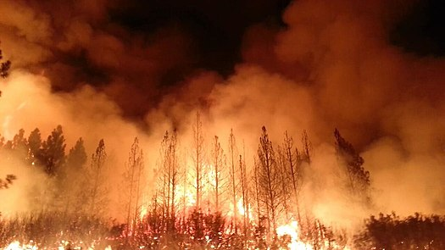 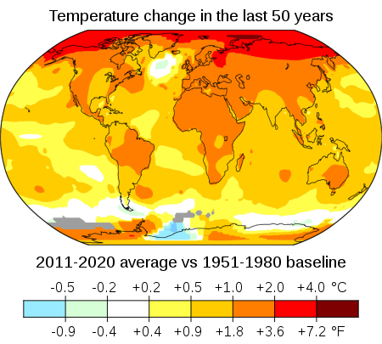

The Earth Observatory Natural Event tracker (EONET):

EONET is a repository of metadata about natural events. EONET is accessible via web services. EONET will drive your natural event application. Worldview has moved natural event discovery to the forefront and allows users to select events-of-interest from a curated list, zooms to the area, and adds the most relevant imagery layers for that type natural event.

PREVENTING WILDFIRES:

1. Report unattended fires
2. Extinguish fire pits and campfires when done.
3. Don’t throw lit cigarettes.
4. Use caution when using flammable liquids.

REFERENCE:

1. Wildfire Wikipedia : <https://en.wikipedia.org/wiki/Wildfire#Natural>
2. Climate change Wikipedia : <https://en.wikipedia.org/wiki/Climate_change>
3. About EONET : <https://eonet.sci.gsfc.nasa.gov/what-is-eonet>

EONET is a repository of metadata about natural events

BY: ABHILASH KUMAR BEHERA and IPSITA BEHERA